GitLab – Jira Integration

Pre-hooks commit

<https://gist.github.com/dberstein/dcc50e171163c3f6e0f23b2b5de5dd49>

<https://gist.github.com/pgilad/5d7e4db725a906bd7aa7>

<https://stackoverflow.com/questions/39786724/gitlab-pre-commit-hook>

<https://docs.gitlab.com/ce/administration/custom_hooks.html>



How to configure GitLab Jira Integration

Mention a Jira Issue ID in a commit message or merge request

GitLab Hyperlinks to the Jira Issue

The Jira issue adds an issue link to the Commit /MR in GitLab

The Jira issue adds a comment reflecting the comment made in GitLab, the comment author, and a link to the commit/MR in GitLab

A commit or MR ‘closes’,’resolves’, or ‘fixes’ a jira Issue ID

When a commit is made on the master or the change is merged to master

GitLab’s merge request page displays a note that it “Closed” the Jira issue, with a link to the issue;

Basic Integration Configuration (Jira Side)

Create a token

It is advisable to have an integration user in Jira

Down left corner avator photo select profile

In the Profile screen

In the down left Corner click in the avatar/managing your account/security/Api Token/Create API Token;

Go to Avator/Profile , Click Manage your accounts

Click Security – Click Create and Manage API tokens.

And then click create API tokens -> Testie -> It will generate new API token -> Copy the token.

Basic Integration Configuration (GitLab side)

Can be done instance-wide as administrator, going to *Admin/Service Templates/Jira

Can be enabled in a project base going to settings/integration/Project services/Jira

To set up, need to inform the following Jira details

Url -> <https://cpcnissgwp01.americas.manulife.net>

Email -> That matches with the token

Token -> Taken from Jira

Go to Gitlab -> Admin Settings -> Service templates -> Jira

Jira Issue Tracker Template

Active Yes

Trigger Commit

Merge Request Yes

WebURL Jira URL

Username or Email (created the token for the user) – Git Lab email id

Transition IDS : Json converter gives the ids (but Try to find out how to take the transition ids)

Setting up Transition

**How to get the Transition IDs.**

[**https://confluence.atlassian.com/adminjiracloud/advanced-workflow-configuration-776636620.html**](https://confluence.atlassian.com/adminjiracloud/advanced-workflow-configuration-776636620.html)

Triggers

Jira administrators can configure triggers in Jira workflows that respond to events in your linked development tools. This allows you to set up your development tools and Jira workflows so that, for example, when a developer creates a branch to start work on an issue in Bitbucket, the issue will automatically be transitioned from 'Open' to 'In progress'.

**Configure triggers**

To see, or to set, triggers for a transition, edit the workflow that contains the transition, select the transition, then click **Triggers** in the properties panel for the transition.

**To add a trigger to a transition:**

1. Select the Jira icon (https://confluence.atlassian.com/adminjiracloud/files/946613651/946613716/1/1520474494630/core.png, https://confluence.atlassian.com/adminjiracloud/files/946613651/946613719/1/1520474554077/software.png, https://confluence.atlassian.com/adminjiracloud/files/946613651/946613718/1/1520474568265/servicedesk.png, or https://confluence.atlassian.com/adminjiracloud/files/946613651/946613717/1/1520474599238/jirafamily.png) > **Jira settings** > **Issues**.
2. Click **Workflows** and then **Edit** for the relevant workflow.
3. In diagram mode, select the transition arrow. In text mode, select the transition's name from the **Transitions (id)**column.
4. In diagram mode, click **Triggers** in the properties panel to show the triggers configured for the transition. In text mode, select the **Triggers** tab.
5. Click **Add trigger** on the **Triggers** tab to configure a trigger.

So it will provide the link under the user story

**Commenting with Jira Integration**

Administrator mentioned this issue in a commit of (Link to Gitlab log) ‘SMD-3’ #Comment I need to get more information on this’

Configuring GitLab Jira Integration

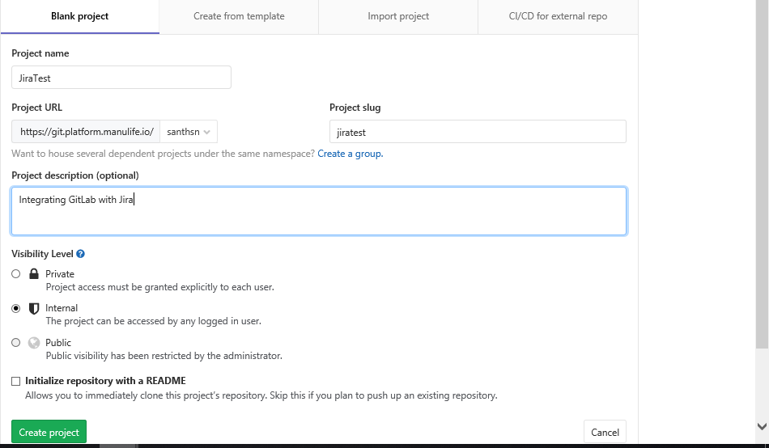

Added simple html file in the repository.

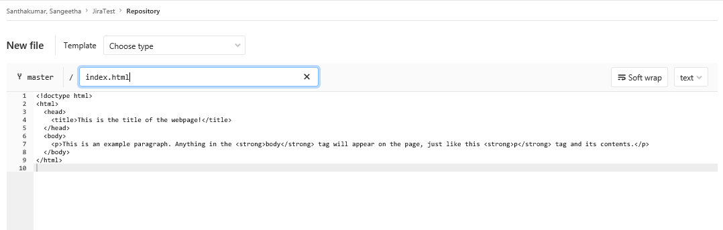

Committing messages

